**Ideation Phase**

**Empathize & Discover**

|  |  |
| --- | --- |
| Date | 15 April 2025 |
| Team ID | SWTID1743870576 |
| Project Name | SpendSmart: Your Personal Finance Companion |
| Maximum Marks | 4 Marks |

**Empathy Map Canvas:**

An empathy map is a simple, easy-to-digest visual that captures knowledge about a user’s behaviours and attitudes.

It is a useful tool to helps teams better understand their users.

Creating an effective solution requires understanding the true problem and the person who is experiencing it. The exercise of creating the map helps participants consider things from the user’s perspective along with his or her goals and challenges.

An **Empathy Map** is a collaborative visualization tool used to articulate what we know about a particular user type. It helps teams understand and align around the user’s perspective by breaking down their behaviors, thoughts, feelings, and needs. It is often used during the **ideation and discovery phase** of product development to build **user-centered solutions**.

Empathy maps help answer questions such as:

* What is the user experiencing?
* What are they thinking and feeling?
* What are their challenges and motivations?
* How can we best solve their problems?

### ****Application to**** ****SpendSmart: Your Personal Finance Companion****

## The empathy map becomes a crucial UX tool to understand the everyday user (e.g., students, professionals, homemakers) and their journey in managing personal finances.

## ****Why is the Empathy Map Important for SpendSmart: Your Personal Finance Companion?****

* Helps the development team build features that address real user concerns
* Aids in creating a more intuitive and user-friendly UI/UX
* Guides content and communication strategy (e.g., what messages users respond to)
* Ensures the solution is empathetic, practical, and user-centric, not just technically sound

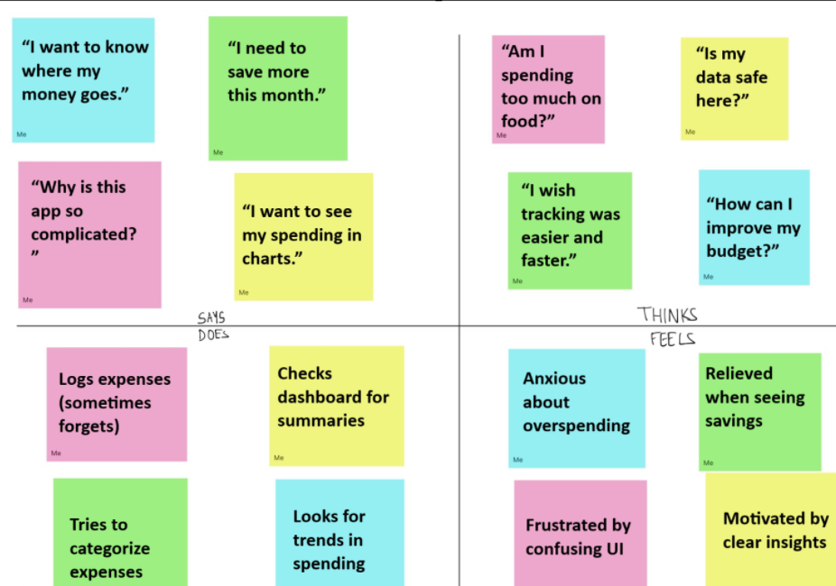

## ****User Needs (for Expense Tracker Users)****

These are the essential desires or features that the user expects from a rental platform.

* Simple and quick way to log expenses and income
* Ability to categorize transactions (e.g., Food, Travel, Rent)
* Visual summaries (charts/graphs) for easy understanding
* Secure and private data storage
* Mobile-friendly and easy-to-use interface
* Real-time updates and instant feedback on spending
* Option to edit or delete entries easily
* Export data for record-keeping
* Personalized insights or suggestions for saving

## ****Pain Points (for Expense Tracker Users)****

These represent the challenges or frustrations that users commonly face with current platforms.

* Forgetting to log expenses or tedious manual entry
* Lack of flexible categories for transactions
* Overwhelming or confusing user interfaces
* No clear visualizations or summaries
* Security and privacy concerns about financial data
* No reminders or notifications to log expenses
* Difficulty in understanding spending patterns
* Inability to access the tracker on multiple devices